OUR LOGO

Our logo depicts Mother Mary and her child inside a boab tree in full bloom. Through the guidance of Mary and Jesus, our students are supported and nurtured in their faith and learning as they grow into young adults. The boab tree represents our parents and the school community, who. Like the boab tree provide shelter, food, water and protection as our children flourish.

OUR VISION
Holy Rosary School is a vibrant, Catholic primary school serving the town of Derby, cultivating pride in culture, wellbeing and achieving to their full potential.

We aim to build resilience and strong hearts in our students so they can face the future with pride, respect and hope.

OUR BELIEFS AND VALUES

We are a Christ-centred community where we learn, we care, we serve, we pray and aim to become responsible global citizens.

We provide an inclusive curriculum that caters for all students in a safe and welcoming environment and where all are encouraged to take ownership of their learning and behaviour through the Gospel values.

QUALIFICATIONS AND TEACHING STAFF

Many of our staff have multiple degrees in various areas of expertise which serve to add to the depth of knowledge and skills available for staff to provide a well-rounded education for our students. Staff hold the following qualifications:

- Bachelor of Primary Education
- Bachelor of Education (Early Years)
- Graduate Diploma in Education
- Masters Degree (Leadership)
- Masters Degree (Religious Education)

WORKFORCE COMPOSITION

Teaching staff are recruited through the CEWA Kimberley Calling program, through initial interviews and then a second interview at the school level.

Non-teaching staff are recruited through local advertising and interviews are conducted at the school level.

Current staff composition for 2023

Teaching staff – seven female and one male (one Aboriginal)
Aboriginal Teacher Assistants – four female
Non-Aboriginal Teacher Assistants – two female
Administration staff – three females
STUDENT ATTENDANCE

Regular attendance has been recognised as a major factor in student success. Throughout the year there are several initiatives that recognise regular attendance at school. In 2023, a partnership continued with Mount Gibson Mining (Koolan Island) with the company offering a day trip to the island for the top ten attendance students across Years 3 – 6. Staff are inducted in the Attendance Policy and strategies each year, with the policy included in the online Staff Handbook.

Attendance data for 2023 is outlined in the table below:

Whole School | 75%
3K | 73%
K | 69%
PP | 69%
1 | 65%
2 | 77%
3 | 76%
4 | 78%
5 | 66%
6 | 77%

Students were supported to attend school through a partnership with Winun Ngari, where students who are not able to get to and from school are transported by bus. Parents are encouraged to register for long term or short-term assistance. Teachers and support staff work with the families through:

- Text message sent home on day of absence asking for reason of absence.
- Teacher follows up with caregivers for unexplained absences.
- Teacher and support staff conduct a home visit to address issues around reluctance to attend school.
- Attendance plans created in consultation with student, family and appropriate staff.
- Referral to Derby Students at Risk, after all processes have not improved student attendance.

NAPLAN ANNUAL ATTENDANCE

The 2023 NAPLAN data reflects a positive trend across English and Mathematics. A summary of the data is included below:

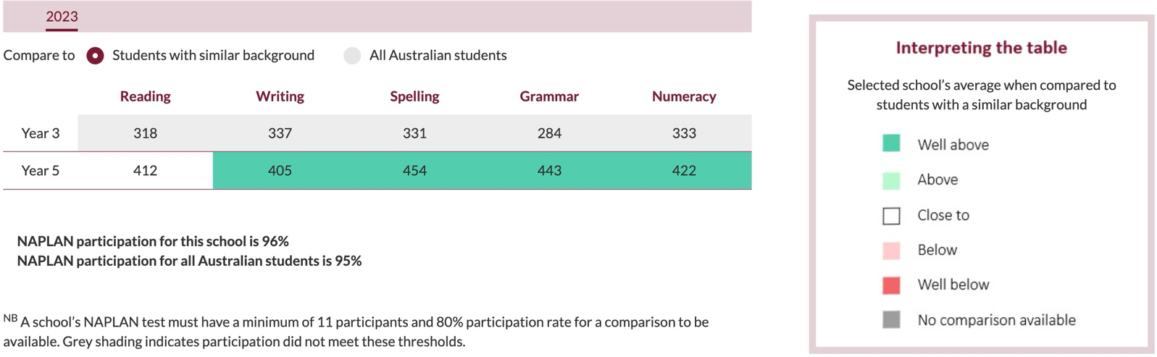

PARENT, STUDENT AND TEACHER SATISFACTION

The climate survey was conducted in 2023 with staff, students and parents invited to participate. The data was only collected from staff and students as there were not enough responses from parents for valid data to be obtained.

The survey showed that students were happy to come to school, knew what was expected of them, were enjoying their learning and felt safe when at school. Areas for growth are that as a school there needs to be less disruptive behaviours in the classroom and student academic resilience.

The survey showed that staff feel that our Catholic Identity was strong in practise and in action, high job satisfaction and energy, and equity and diversity was high. Areas for growth are that teachers need to set clear expectations and rules, and staff collegiality needs to be better.

SCHOOL INCOME

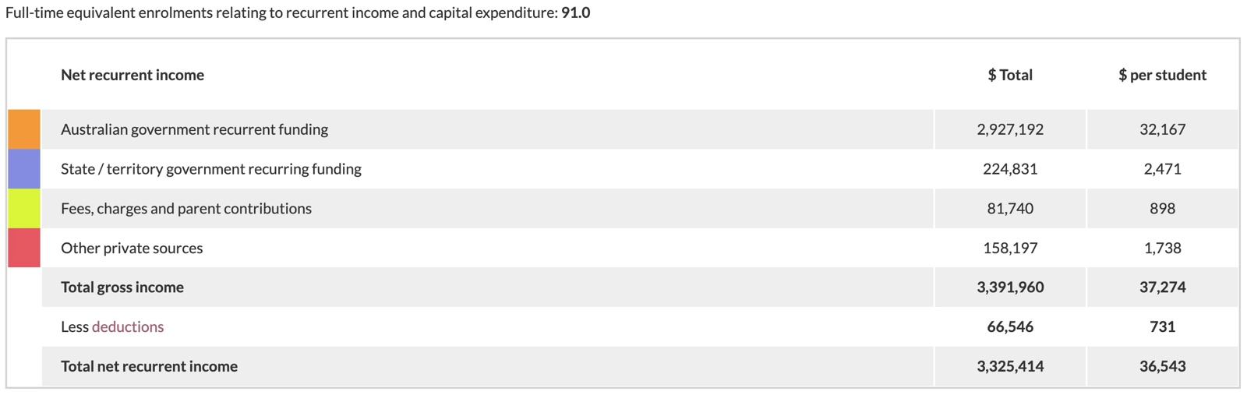

ANNUAL SCHOOL IMPROVEMENT

A review of the School Improvement Plan identified that many of the goals set for the school were no longer a priority in the school, due to the numerous changes in the school leadership. Goals that were being progressed were:

- Implemented professional learning for all teaching staff across the Kimberley through CEWA facilitating Literacy and Numeracy professional learning in Broome, along with attendance at network meetings for Religious Education, Early Career Teachers Network and Digital Technologies.
- Commenced partnership with Nyunga Aboriginal Women’s Group to commence a Playgroup to support Aboriginal families to feel included in the Holy Rosary community.
- Breakfast and lunch programs continued.
- Implementation of whole school planning template for teaching staff to promote consistency of expectations across the school.

